Project Title
Mini Search Engine
Project Report submitted for the partial fulfilment of grade for the course

Data Structures and Algorithms -3 (25CS2103E)
in

A.Y. 2026-2027

Submitted by
Keerthi Priya Ande roll no: 2520090177
Karnati Laxmi Lahari roll no: 2520090206

Team Number: 5
Section: 12

Under the guidance of
Ms.K.Chandusha,

Asst. Professor, CS&IT
Hyderabad-500090, Telangana, India.

K L (Deemed to be) University
DEPARTMENT OF COMPUTER SCIENCE ENGINEERING / COMPUTER SCIENCE AND INFORMATION TECHNOLOGY/ARTIFICIAL INTELLIGENCE & DATA SCIENCE



DECLARATION

The Mini Project Report entitled “Mini Search Engine” is a record of Bonafide work of Keerthi Priya Ande – 2520090177, Karnati Laxmi Lahari – 2520090206, submitted in partial fulfillment for the award of B. Tech in Computer Science and Engineering/Computer Science and Information Technology/ Artifical Intelligence & data Science to the K L University. The results embodied in this report have not been copied from any other departments/University/Institute.

Keerthi Priya Ande – 2520090177
Karnati Laxmi Lahari – 2520090206

K L (Deemed to be) University
DEPARTMENT OF COMPUTER SCIENCE ENGINEERING / COMPUTER SCIENCE AND INFORMATION TECHNOLOGY
CERTIFICATE

This is to certify that the mini project based report entitled “Mini Search Engine” is a bonafide work done and submitted by Keerthi Priya Ande – 2520090177, Karnati Laxmi Lahari – 2520090206, in partial fulfillment of the requirements for the award of the degree of BACHELOR OF TECHNOLOGY in Department of Computer Science Engineering/ Computer Science and Information Technology/Artificial Intelligence & Data Science, K L (Deemed to be University), during the academic year 2026-2027.

Signature of the Supervisor

Signature of the HOD Signature of the External Examiner

ACKNOWLEDGEMENT

The success in this project would not have been possible but for the timely help and guidance rendered by many people. Our wish to express my sincere thanks to all those who has assisted us in one way or the other for the completion of my project.

Our greatest appreciation to my guide Ms.K.Chandusha, Asst. Professor, CSIT which cannot be expressed in words for his/her tremendous support, encouragement and guidance for this project.

We express our gratitude to Dr. P.Venkateshwar Rao (CSE)/Dr. Khaja Shareef (CSIT)/ Dr. Sreenath Itikela (AI&DS), Head of the Department for Computer Science Engineering/ Department for Computer Science and Information Technology/Department of Artificial Intelligence and Data Science for providing us with adequate facilities, ways and means by which we are able to complete this project-based Lab.

We thank all the members of teaching and non-teaching staff members, and also who have assisted me directly or indirectly for successful completion of this project. Finally, I sincerely thank my parents, friends and classmates for their kind help and cooperation during my work.

Keerthi Priya Ande – 2520090177
Karnati Laxmi Lahari – 2520090206

TABLE OF CONTENTS

S.No. | Contents | Page no.
1. | Abstract | 6
2. | Introduction | 7
3. | Literature survey | 8-9
4. | Problem Statement and Objectives | 10
5. | Hardware and Software requirements | 11
6. | Implementation | 12-15
7. | Results & Discussion | 16-18
8. | Conclusion & Future Scope | 19
9. | References | 20

1.ABSTRACT

The Mini Search Engine / Information Retrieval System is a web-based application developed to demonstrate the practical use of Data Structures and Algorithms in document searching. The system allows users to enter a search query and retrieves the most relevant documents from a collection of stored documents. The backend is developed using Java and Spring Boot, while the frontend is developed using React and Vite.
The system uses an Inverted Index for efficient document lookup and applies multiple searching techniques, including Exact Search, Phrase Search, Fuzzy Search using Levenshtein Distance, and Similarity Search using Jaccard Similarity. These techniques help the system identify relevant documents even when the search query does not exactly match the stored content. A Ranking algorithm is then used to arrange the retrieved documents according to their relevance scores.
The final results are displayed through a simple and interactive web interface, showing the document title, content, document ID, and relevance score. The project demonstrates how different Data Structures and Algorithms can work together to build an efficient and practical Information Retrieval System.
Team Name: 5
Team Logo (if any):
Team Members:
- Keerthi Priya Ande, 2520090177
- Karnati Laxmi Lahari, 2520090206

- INTRODUCTION

In the modern digital world, a huge amount of information is available in the form of documents, web pages, articles, and other digital resources. Finding the required information manually from a large collection of documents can be time-consuming and inefficient. Search engines and Information Retrieval Systems help solve this problem by allowing users to enter a query and quickly retrieve information that is relevant to their requirements.
Information Retrieval (IR) is the process of finding relevant information from a collection of documents based on a user's search query. An effective search system should not only find documents containing the searched words but should also determine which documents are more relevant to the user's query. This requires efficient data organization, searching techniques, similarity calculations, and ranking methods.
The Mini Search Engine / Information Retrieval System developed in this project demonstrates how Data Structures and Algorithms can be applied to build a simple search engine. The system maintains a collection of documents and processes user queries to identify relevant documents. An Inverted Index is used to organize words and their associated documents, allowing the system to perform efficient searches.
The project incorporates several searching and matching techniques. Exact Search is used to identify direct matches, while Phrase Search checks whether a complete search phrase occurs in a document. Fuzzy Search uses Levenshtein Distance to handle small differences or spelling variations between words. Similarity Search uses Jaccard Similarity to measure the similarity between the query and document content. These techniques provide different ways of identifying relevant information.
After the matching process, the system calculates a relevance score for the documents. The Ranking algorithm then sorts the results according to their scores so that the most relevant documents are displayed first. The user can see the document title, content, document ID, and relevance score through the web interface.
The project uses Java and Spring Boot for the backend and React with Vite for the frontend. The frontend provides an interactive search interface, while the backend performs the searching, scoring, and ranking operations. Overall, the project demonstrates how multiple Data Structures and Algorithms can work together to create a functional and efficient Information Retrieval System.

- LITERATURE SURVEY

1. Apache Lucene
Apache Lucene is an open-source Java library designed for information retrieval and text searching. It uses indexing techniques, particularly inverted indexes, to efficiently search collections of documents. Lucene provides functionality for text analysis, indexing, querying, and relevance scoring. Our project is related to Lucene because we also use an inverted index and multiple search techniques to retrieve relevant documents.
Apache Lucene – https://lucene.apache.org/
2. Apache Solr
Apache Solr is an open-source search platform built on top of Apache Lucene. It supports keyword searching, indexing, complex queries, and relevance tuning for document retrieval. Solr can work with structured and unstructured data and provides advanced search features such as text analysis and ranking. Our project follows a similar basic retrieval pipeline but implements the main DSA concepts ourselves using Java.
Apache Solr – https://solr.apache.org/
3. Elasticsearch
Elasticsearch is a distributed, open-source search and analytics engine used for full-text search and large collections of documents. It is based on Apache Lucene and uses inverted indexes for efficient retrieval. Search queries are processed and documents are scored according to their relevance. Our project is similar in its use of document indexing, searching, and relevance-based ranking, although our system is a smaller educational implementation.
Elasticsearch – https://www.elastic.co/elasticsearch
4. Apache Jena Full-Text Search
Apache Jena Full-Text Search provides full-text searching within applications that use the Jena framework. It integrates full-text search with SPARQL and uses Lucene-based indexing to retrieve relevant text. The system demonstrates how indexed document content can be searched efficiently instead of scanning every document. This is related to our project because our Mini Search Engine also uses an index to improve document retrieval.
Apache Jena – https://jena.apache.org/
5. Stanford Information Retrieval Project
The Stanford Information Retrieval Project demonstrates the construction of an information retrieval system using document collections. One of its important components is an inverted index, which maps terms to the documents in which they occur. The project also demonstrates how indexing can be used to support efficient querying of document collections. This concept directly relates to the inverted-index component implemented in our Mini Search Engine.
Stanford Information Retrieval Project - https://web.stanford.edu/class/cs276b/2003/project.html
6. DSpace Digital Repository Search
DSpace is a digital repository platform used to store and provide access to digital documents and research materials. Its search functionality uses Apache Solr for document search and organization, with Solr relying on Apache Lucene for much of its search and indexing functionality. This demonstrates how indexing and search technologies can be applied to large collections of digital documents. Our project applies similar concepts on a smaller scale for educational purposes.
DSpace – https://dspace.org/
7. Semantic Search for Information Retrieval
Modern information retrieval systems increasingly use semantic search to understand the meaning of queries and documents rather than relying only on exact keyword matches. Research in this area includes techniques such as BM25, dense retrieval, and neural retrieval models. These approaches aim to improve retrieval when the query and document use different words but have related meanings. Our project currently focuses on classical DSA-based techniques such as indexing, fuzzy matching, similarity calculation, and ranking, providing a foundation that could later be extended toward semantic search.
Semantic search - https://arxiv.org/abs/2508.17694?utm_source

- Problem Statement and Objectives

Problem Statement: To develop an efficient Mini Search Engine that retrieves and ranks relevant documents from a collection based on a user's search query.

Problem Description: Searching manually through a collection of documents can be time-consuming and inefficient. The project aims to provide a simple Information Retrieval System that uses indexing, searching, similarity, and ranking techniques to quickly identify relevant documents.

Objectives:
- To develop a simple and efficient Information Retrieval System for searching a collection of documents.
- To implement an Inverted Index for efficient document and keyword lookup.
- To implement Exact Search and Phrase Search for identifying relevant keyword and phrase matches.
- To implement Fuzzy Search using Levenshtein Distance to handle small spelling differences in search queries.
- To implement Similarity Search using Jaccard Similarity to measure the similarity between the query and document content.
- To calculate relevance scores for retrieved documents based on different matching techniques.
- To rank search results so that the most relevant documents are displayed first.
- To provide a simple web-based interface where users can enter queries and view document titles, content, IDs, and relevance scores.

- HARDWARE AND SOFTWARE REQUIREMENTS

Hardware Requirements:
- Laptop/Desktop Computer – Used for developing, running, and testing the Mini Search Engine.
- Minimum 4 GB RAM – Required to run the Java backend, React frontend, and development tools smoothly.
- Internet Connection – Required for installing project dependencies and accessing required development resources.

Software Requirements:
- Operating System: Windows 10/11
- Programming Language: Java
- Backend: Spring Boot
- Frontend: React with Vite
- Development Environment: Visual Studio Code
- Build Tool: Maven
- Web Browser: Google Chrome / Microsoft Edge

- IMPLEMENTATION

Module 1: Inverted Index
The Inverted Index stores the relationship between words and the documents in which those words occur. It helps the search system locate relevant documents efficiently.

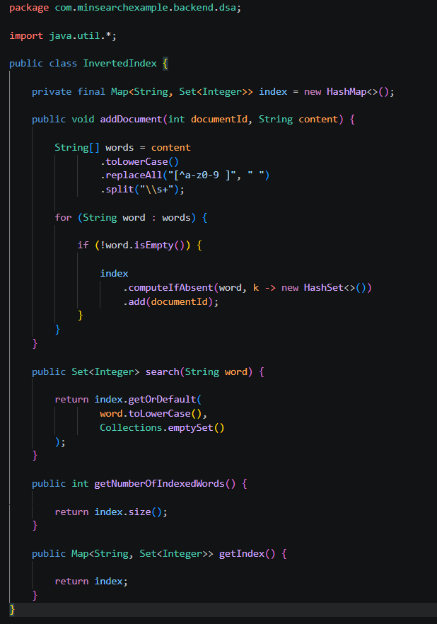
Working:
The document text is divided into individual words and each word is mapped to the corresponding document ID. When a user searches for a word, the index can quickly identify the documents associated with that word.

Module 2: Fuzzy Search using Levenshtein Distance
Fuzzy Search allows the system to identify words that are slightly different from the search query. It uses Levenshtein Distance, which calculates the minimum number of insertions, deletions, or replacements required to transform one word into another.
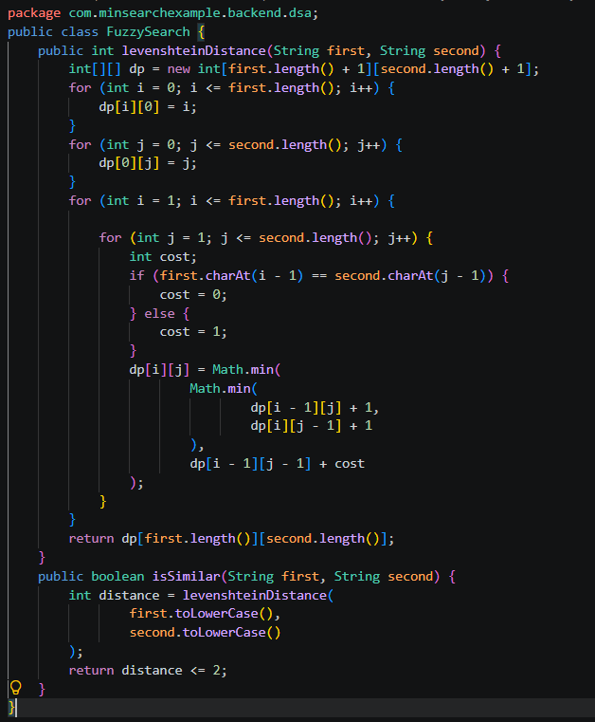
Working:
The algorithm compares two words and calculates their edit distance. If the distance is 2 or less, the words are considered similar.

Module 3: Similarity Search using Jaccard Similarity
The Similarity Search compares the words in the search query with the words in a document. Our project uses Jaccard Similarity.
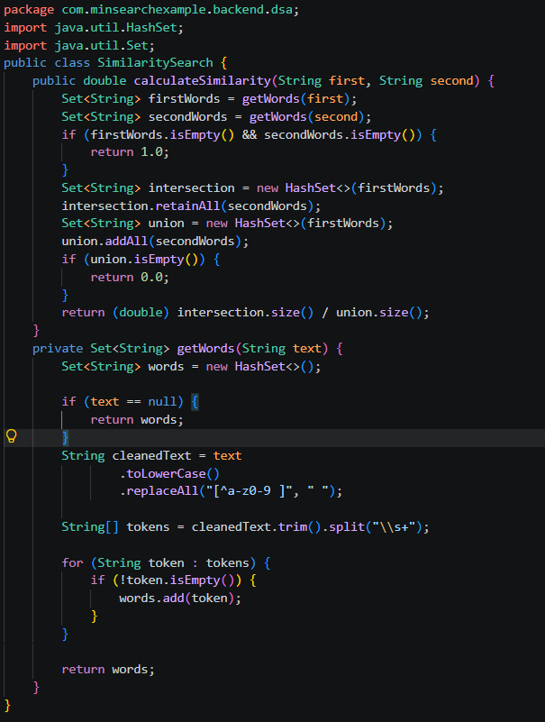
Working:
The query and document are converted into sets of words. The intersection and union of the sets are calculated, and the resulting Jaccard value represents their similarity.

Module 4: Ranking
After searching and calculating relevance scores, the Ranking module sorts the documents from the highest score to the lowest score.
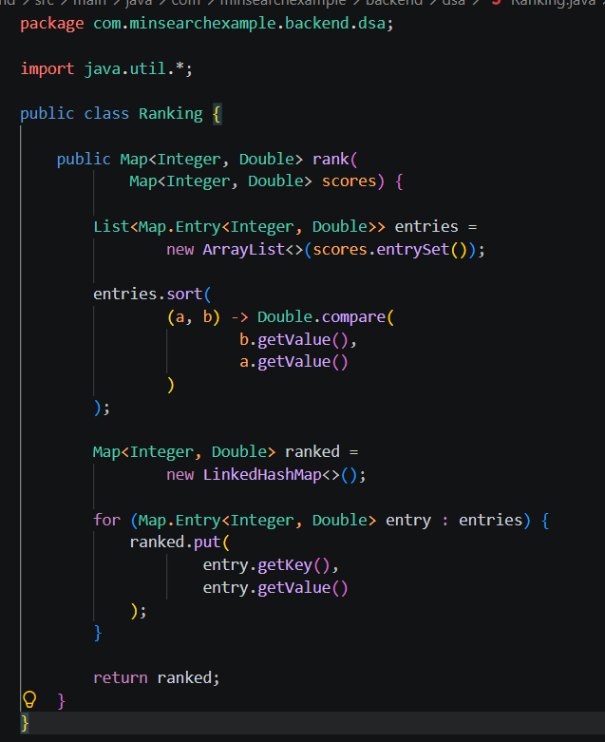
Working:
The ranking algorithm compares the relevance scores of all matching documents and arranges them in descending order. Therefore, the document with the highest relevance score is displayed first.

- RESULTS & DISCUSSION

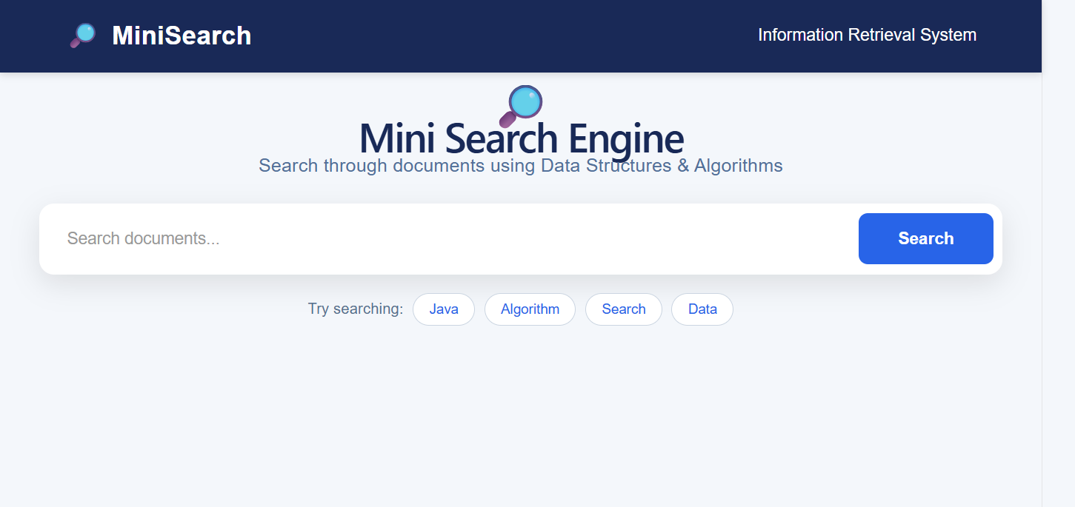

The Mini Search Engine provides a user-friendly interface where users can enter keywords and search through the available documents. The interface also provides suggested search terms such as Java, Algorithm, Search, and Data.

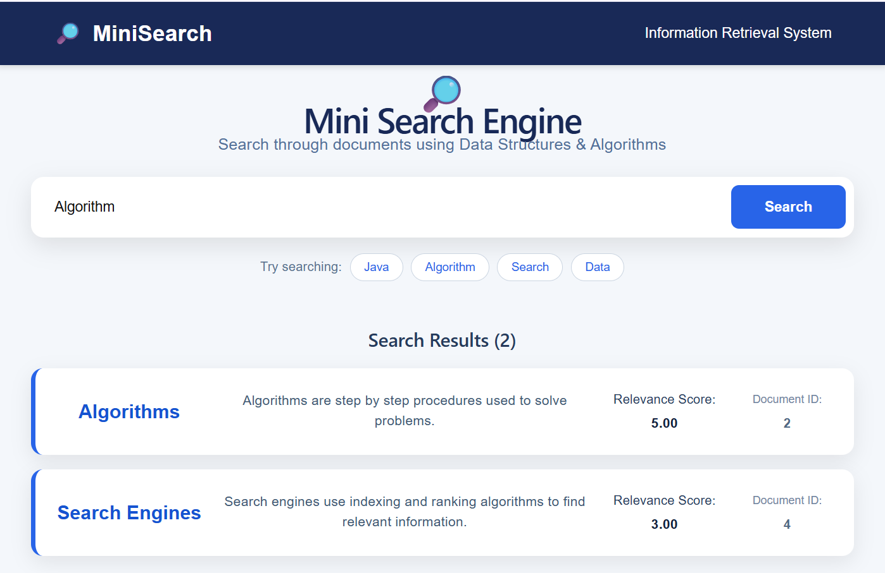
When the user searches for “Algorithm”, the system retrieves relevant documents and displays their title and content. Each result is provided with a Relevance Score and Document ID to indicate its ranking and identity.

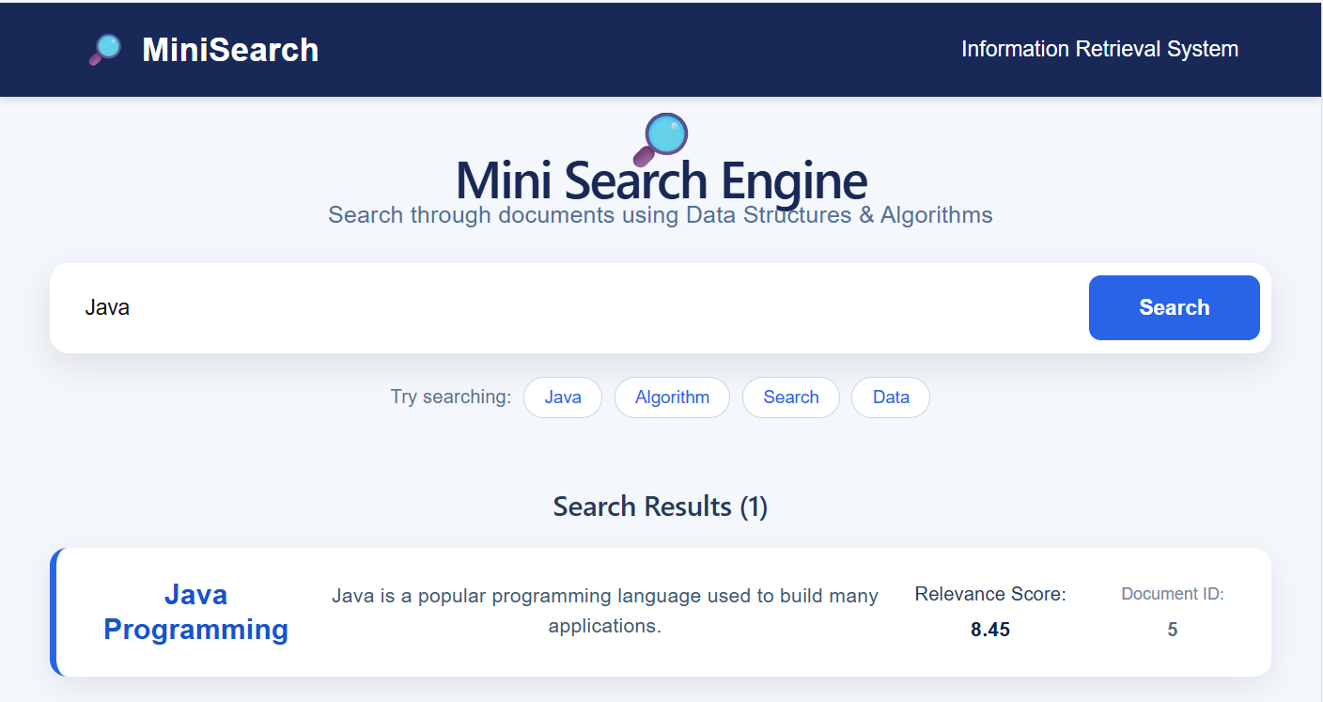

The system searches the document collection for the “Java” query and displays the matching Java Programming document. The result includes the document content, relevance score, and document ID.

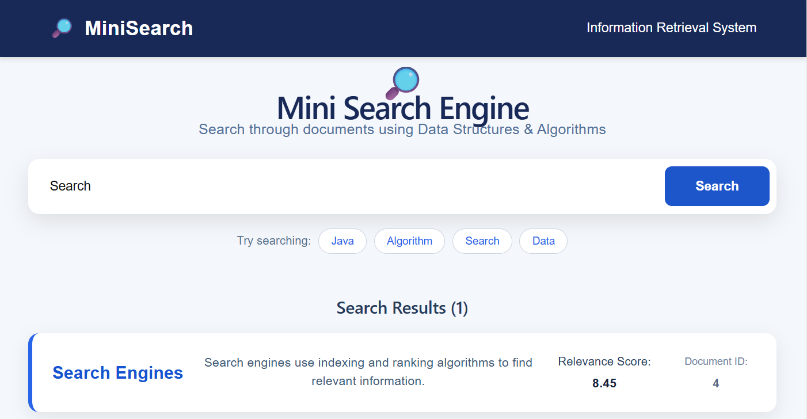
For the “Search” query, the system identifies documents related to search and displays them according to their relevance. The ranking mechanism places the higher-scoring documents before lower-scoring results.
Results Summary
The implemented system successfully demonstrates document retrieval using indexing, searching, similarity calculation, and ranking techniques. The final web interface displays the retrieved documents along with their relevance scores and document IDs, demonstrating the practical application of Data Structures and Algorithms.

- CONCLUSION & FUTURE SCOPE

8.1 Conclusion
The Mini Search Engine / Information Retrieval System was successfully developed to demonstrate the practical application of Data Structures and Algorithms in document searching. The system allows users to enter a search query and retrieve relevant documents from a collection.
The project successfully implemented an Inverted Index, Exact Search, Phrase Search, Fuzzy Search using Levenshtein Distance, Similarity Search using Jaccard Similarity, and Ranking. These techniques work together to identify relevant documents, calculate relevance scores, and display the most relevant results first.
The developed web application provides a simple and interactive interface where users can view the document title, content, document ID, and relevance score. Overall, the project achieved its main objectives and demonstrates how different searching, similarity, and ranking algorithms can be combined to build a functional Information Retrieval System.
8.2 Future Scope
The system can be enhanced in the future by introducing additional features and improving its searching capabilities.
Near-Term Enhancements
- Add a larger collection of documents.
- Improve the user interface and search experience.
- Add better query processing and keyword handling.
- Improve the relevance-scoring mechanism.
Medium-Term Enhancements
- Add database support for storing and managing documents.
- Implement advanced ranking algorithms.
- Support document upload and automatic indexing.
- Improve fuzzy and semantic search capabilities.
Long-Term Enhancements
- Develop a large-scale search system capable of handling millions of documents.
- Implement Artificial Intelligence and Machine Learning techniques for improved search relevance.
- Add Natural Language Processing for understanding complex user queries.
- Support real-time indexing and searching of dynamically added documents.
- REFERENCES

1. Apache Lucene, “Apache Lucene – Powerful Search Library,” https://lucene.apache.org/
2. Apache Solr, “Apache Solr – Open Source Search Platform,” https://solr.apache.org/
3. Elasticsearch, “Elasticsearch – Distributed Search and Analytics Engine,” https://www.elastic.co/elasticsearch
4. Apache Jena, “Text Query – Full Text Search,” https://jena.apache.org/documentation/query/text-query.html
5. Stanford University, “Information Retrieval Project,” https://web.stanford.edu/class/cs276b/2003/project.html
6. DSpace, “DSpace – Open Source Repository Software,” https://dspace.org/
7. Manning, C. D., Raghavan, P., and Schütze, H., Introduction to Information Retrieval, Cambridge University Press.
8. Cormen, T. H., Leiserson, C. E., Rivest, R. L., and Stein, C., Introduction to Algorithms, MIT Press.
9. Apache Software Foundation, “Maven – Build Management Tool,” https://maven.apache.org/
10. Spring, “Spring Boot Documentation,” https://spring.io/projects/spring-boot

